Zombie Process

Whenever we run a program it creates a parent process and a lot of child processes. All of these child processes use resources such as memory and CPU allocated to them by the kernel.

Once these child processes have finished executing they send an Exit call and die. This Exit call has to be read by the parent process which later calls the wait command to read the exit_status of the child process so that the child process can be removed from the processes table. If the Parent reads the Exit call correctly sent by the Child Process, the process is removed from the processes table.

But, if the parent fails to read the exit call from the child process, the child process which has already finished its execution and is now dead will not be removed from the processes table. Hence, the process that has finished execution but is still in processes table is called a zombie process.

Find Zombie Process using htop

Look for ‘Z’ in the status ‘S’ column in htop

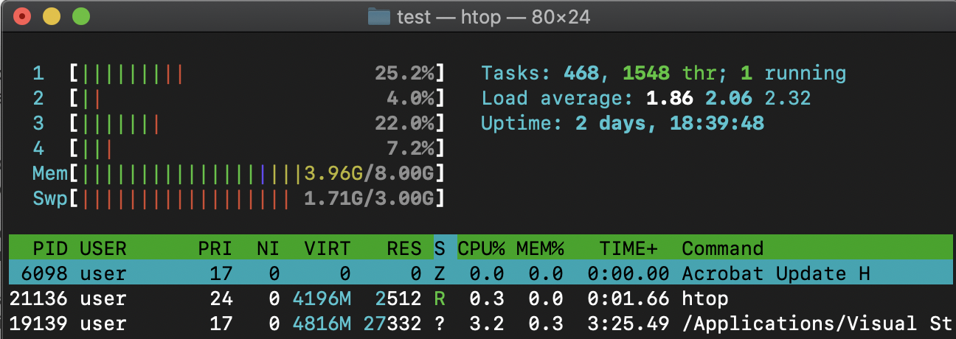

Kill Zombie Process using htop

$ sudo kill -9 6098s

